**DAY 1**

**YAZHINI S (DE130)**

**DATE: 04-11-2024**

**VARIOUS DATA FIELDS:**

Data engineering

Data Analytics (ETL, ELT etc)

Data Science

**Data engineering:**

Data engineering is the discipline focused on designing, building, and managing systems.

**Data warehouse concepts:**

* Database – Collection of data
* Data center – hub where all data are stored as shown below:

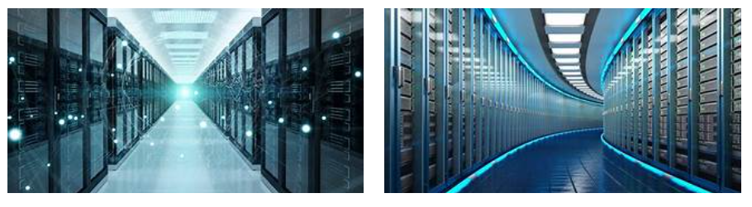

* Data warehouse – store subj oriented, integrated, time variant, non-volatile collection of data
* Data mart
* DSS (Decision Support System) concepts – OLTP, OLAP

**1. OLTP -** **Online Transaction Processing:**

An example considered for OLTP System is ATM Center a person who authenticates first will receive the amount first and the condition is that the amount to be withdrawn must be present in the ATM.

**OLTP Applications:**

ATM center is an OLTP application.

OLTP handles the ACID properties during data transactions via the application.

It’s also used for Online banking, Online airline ticket booking, sending a text message, add a book to the shopping cart.

**2. Online Analytical Processing (OLAP)**

Online Analytical Processing (OLAP) refers to software tools used for the analyse the data helps for business decision-making processes. These systems are part of data warehousing and business intelligence, enabling users to do things like trend analysis, financial forecasting, and any other form of in-depth data analysis.

**OLAP Examples**

Spotify analyzed songs by users to come up with a personalized homepage of their songs and playlists.

Netflix movie recommendation system

**What is big data?**

Big data engineers handle large-scale data processing and storage solutions.

We also discussed some other related topics with block diagrams in the PPT. (refer the drive ppt)

SQL PART:

Storing Data in a Table

Updating Data in a Table

Deleting Data from a Table

Retrieving Specific Attributes

Retrieving Selected Rows

Filtering Data: WHERE Clauses

Filtering Data: IN, DISTINCT, AND, OR, IN, BETWEEN, LIKE, Column & table aliases

**-- 1: Create the Employee Table**

CREATE TABLE Employee (

EmployeeID INT PRIMARY KEY,

FirstName NVARCHAR(50),

LastName NVARCHAR(50),

Age INT,

Department NVARCHAR(50),

Salary DECIMAL(10, 2)

);

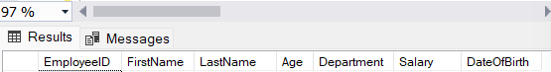

**-- 2: Insert Sample Data into Employee Table**

INSERT INTO Employee (EmployeeID, FirstName, LastName, Age, Department, Salary)

VALUES

(1, 'Priya', 'Mehta', 30, 'IT', 60000),

(2, 'Raj', 'Tamizhavan', 28, 'Marketing', 50000),

(3, 'Ananya', 'Sharma', 35, 'HR', 55000),

(4, 'Kiran', 'Kumar', 40, 'IT', 70000);

**-- 3: Insert New Data (Storing Data in a Table)**

INSERT INTO Employee (EmployeeID, FirstName, LastName, Age, Department, Salary)

VALUES (5, 'Amit', 'Verma', 25, 'Sales', 45000);

**-- 4: Update Data in the Table (Updating Data)**

UPDATE Employee

SET Salary = 75000

WHERE EmployeeID = 4;

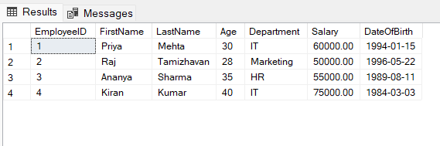

**-- 5: Delete Data from the Table (Deleting Data)**

DELETE FROM Employee

WHERE EmployeeID = 5;

-- 6: Retrieve Specific Attributes (Retrieving Specific Columns)

SELECT FirstName, LastName, Department

FROM Employee;

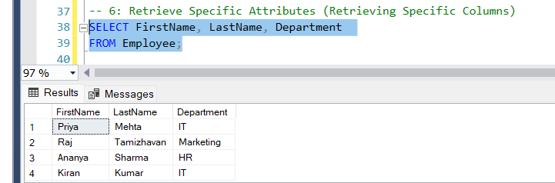

**-- 7: Retrieve Selected Rows (Retrieving Selected Rows)**

SELECT *

FROM Employee

WHERE Department = 'IT';

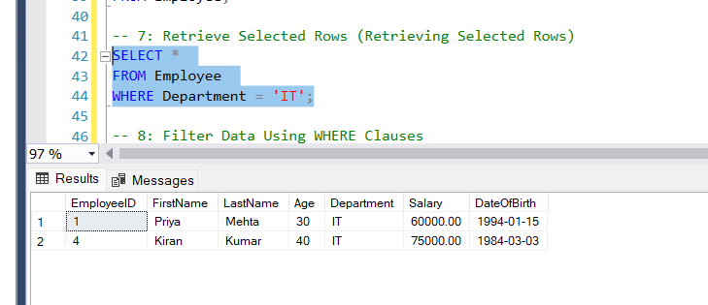

**-- 8: Filter Data Using WHERE Clauses**

SELECT *

FROM Employee

WHERE Salary > 55000;

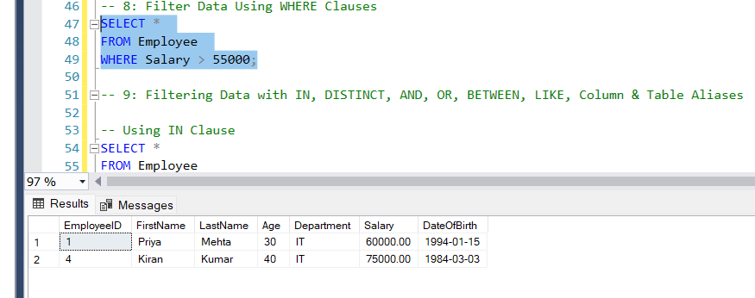

**-- 9: Filtering Data with IN, DISTINCT, AND, OR, BETWEEN, LIKE, Column & Table Aliases**

-- Using IN Clause

SELECT *

FROM Employee

WHERE Department IN ('IT', 'Marketing');

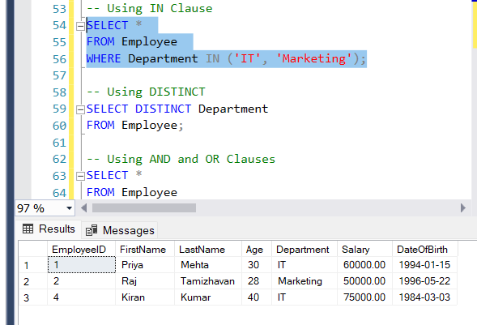

-- Using DISTINCT

SELECT DISTINCT Department

FROM Employee;

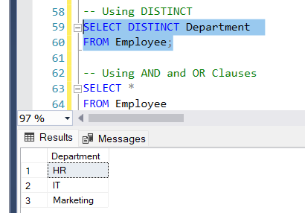

-- Using AND and OR Clauses

SELECT *

FROM Employee

WHERE Age > 30 AND Department = 'IT';

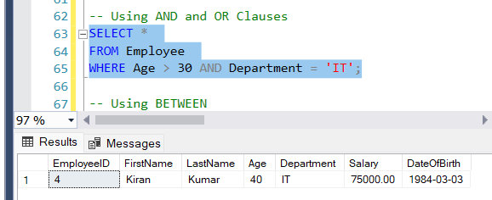

-- Using BETWEEN

SELECT *

FROM Employee

WHERE Age BETWEEN 28 AND 40;

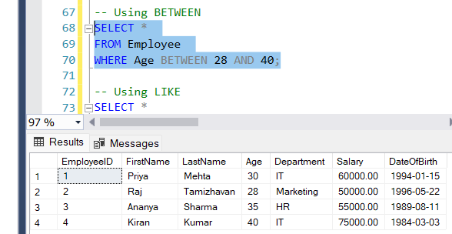

-- Using LIKE

SELECT *

FROM Employee

WHERE FirstName LIKE 'P%';

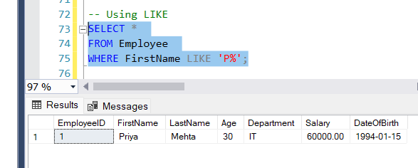

-- Using Column and Table Aliases

SELECT E.FirstName AS FName, E.LastName AS LName, E.Salary AS MonthlySalary

FROM Employee AS E;

